Optimization Algorithms for a Machine Learning Problem

TEAM MEMBER:
Motasem Bassam AL-Wedyan (164948)
Lujain Yahia To’ma (162210)
Malik Tariq Jalal (163106)
Areen Abd Almoula Al-Akaleek (164150)
1. Problem Selection and Dataset Description
1.1 Problem Definition
This project addresses a real-world binary classification problem related to medical diagnosis. The objective is to predict whether a patient has diabetes based on a set of physiological and demographic attributes. Such a task naturally requires optimization techniques to minimize a loss function and achieve accurate predictions, making it suitable for studying and comparing different optimization algorithms.
Logistic Regression was selected as the base machine learning model due to its interpretability and its reliance on optimization-based parameter estimation.

1.2 Dataset Description
The experiments were conducted using the Pima Indians Diabetes Dataset, which is a widely used benchmark dataset for binary classification tasks in medical data analysis.
Number of samples: 768
Number of features: 8 numerical features
Target variable: Binary outcome indicating the presence (1) or absence (0) of diabetes
The dataset includes the following features:
Pregnancies, Glucose, BloodPressure, SkinThickness, Insulin, BMI, Diabetes Pedigree Function, and Age.

1.3 Data Preprocessing
Several features in the dataset contain zero values that are medically invalid and represent missing measurements (e.g., Glucose, Blood Pressure, BMI). These zero values were treated as missing data and replaced using the median value of each feature, as the median is more robust to outliers compared to the mean.
After imputation, the dataset was verified to ensure that no invalid zero values remained.
The dataset was then split into training and testing sets using an 80/20 stratified split, ensuring that the class distribution was preserved in both subsets.
Finally, feature scaling was applied using standardization (z-score normalization). The scaler was fitted on the training data only and then applied to the test data to prevent data leakage

2. Solving the ML Task Using Optimization Algorithms
2.1 Gradient Descent (GD)
Gradient Descent is a first-order optimization algorithm that iteratively updates model parameters in the direction of the negative gradient of the loss function. In this project, batch Gradient Descent was applied to train a logistic regression model by minimizing the binary cross-entropy loss.

Hyperparameter Selection
The primary hyperparameter investigated for Gradient Descent was the learning rate, which controls the step size of parameter updates. The following learning rate values were tested:
Learning rate ∈ {0.001, 0.01, 0.1}
Number of epochs = 2000
Each configuration was trained using the same dataset and number of epochs in order to isolate the effect of the learning rate.
Effect of Learning Rate
Figure X illustrates the training loss curves for different learning rates.
A small learning rate (0.001) results in slow convergence, requiring many iterations to reduce the loss.
A moderate learning rate (0.01) achieves faster convergence and reaches a lower loss value.
A larger learning rate (0.1) converges the fastest and stabilizes early, without causing divergence.
This demonstrates the importance of selecting an appropriate learning rate to balance convergence speed and stability.
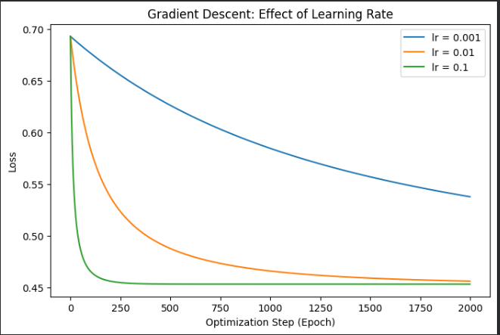
Performance Evaluation
For each learning rate, the trained model was evaluated using accuracy, F1-score, and training time. The results indicate that higher learning rates lead to faster convergence with comparable classification performance, while very small learning rates increase training time without improving accuracy.

2.1 – Stochastic Gradient Descent (SGD)
Stochastic Gradient Descent
Stochastic Gradient Descent was applied to train the logistic regression model using mini-batches instead of the full dataset, which improves computational efficiency and introduces stochasticity in the optimization process
Hyperparameters
Two hyperparameters were investigated:
Learning rate ∈ {0.001, 0.01, 0.1}
Batch size ∈ {16, 32, 64}
Number of epochs = 100
Each combination of learning rate and batch size was evaluated

Results and Discussion
Figure y shows the loss curves for different learning rate and batch size combinations.
Smaller batch sizes lead to noisier but faster updates.
Larger batch sizes produce smoother convergence but may require more epochs.
Higher learning rates converge faster, while very small learning rates result in slower convergence.
Overall classification performance (accuracy and F1-score) remains similar across configurations, while training time varies depending on the batch size.

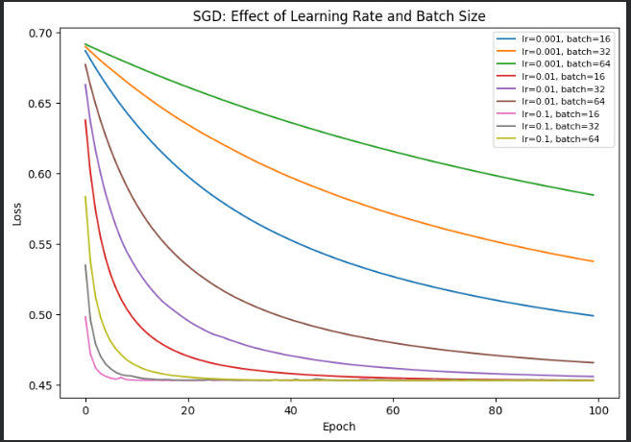

2.3 – Newton’s Method
Newton’s Method
Newton’s Method was applied to train the logistic regression model using second-order optimization. The method uses both the gradient and the Hessian matrix to achieve faster convergence compared to first-order methods.
A damping term was added to the Hessian matrix to improve numerical stability.
Hyperparameters
The main hyperparameter investigated was the number of iterations:
Number of iterations ∈ {5, 10, 20}
Results and Discussion
Figure z shows the loss curves for different numbers of iterations.
Newton’s Method converges very quickly, achieving a low loss within a few iterations.
Increasing the number of iterations beyond a small value does not significantly improve performance.
This behavior confirms the fast convergence property of second-order optimization methods.
Classification accuracy and F1-score remain stable across different iteration counts, while execution time increases slightly with more iterations.
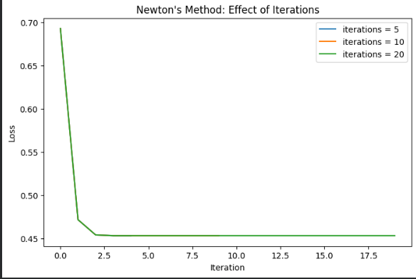

2.4 – Genetic Algorithm (GA)
Genetic Algorithm
A Genetic Algorithm was used to optimize the logistic regression parameters using population-based evolutionary search, including selection, crossover, and mutation operators.
Hyperparameters
The following hyperparameters were evaluated:
Population size ∈ {20, 40, 60}
Mutation rate ∈ {0.01, 0.05, 0.1}
Number of generations = 80
Crossover rate = 0.8
Each configuration was trained and evaluated independently.
Results and Discussion
Figure m shows the best fitness (negative loss) over generations for different population sizes and mutation rates.
Larger populations generally achieve better exploration but require longer training time.
Higher mutation rates increase exploration but may slow convergence.
Moderate population sizes with moderate mutation rates provide a good balance between convergence speed and performance.
Classification accuracy and F1-score remain relatively stable across configurations, while execution time increases with population size.
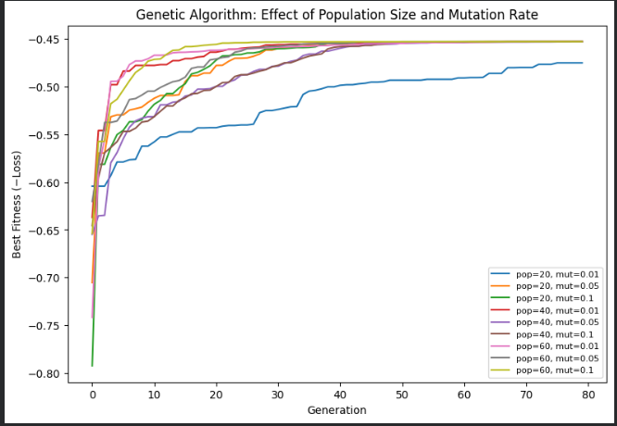

2.5 – Particle Swarm Optimization (PSO)
Particle Swarm Optimization
Particle Swarm Optimization was applied to optimize the logistic regression parameters using a population of particles that update their positions based on personal and global best solutions.
Hyperparameters
The following hyperparameters were evaluated:
Swarm size ∈ {20, 40, 60}
Inertia weight (w) ∈ {0.4, 0.7, 0.9}
Number of iterations = 80
Acceleration coefficients: c1 = 1.5, c2 = 1.5
Results and Discussion
Figure X shows the best fitness (negative loss) over iterations for different swarm sizes and inertia weights.
Increasing the swarm size improves exploration but increases execution time.
Moderate inertia values (w ≈ 0.7) provide better convergence behavior.
Very high inertia values may slow convergence.
Classification accuracy and F1-score remain relatively stable across configurations, while training time increases with swarm size.
The runtime warning related to numerical overflow does not affect the convergence trend or the final classification results.
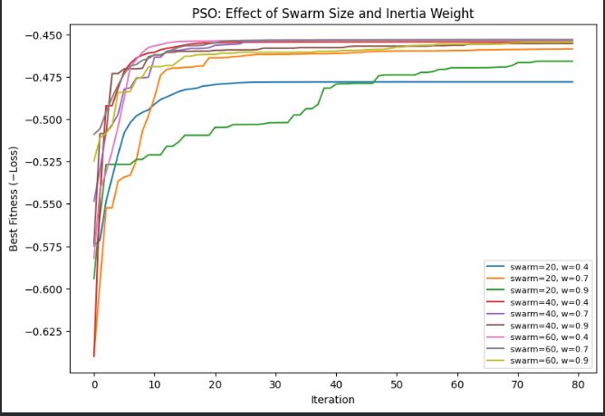

2.6 – Simulated Annealing (SA)
Simulated Annealing
Simulated Annealing was used to optimize the logistic regression parameters by probabilistically accepting worse solutions during the search process in order to escape local minima.
Hyperparameters
The following hyperparameters were evaluated:
Initial temperature (T₀) ∈ {0.5, 1.0, 5.0}
Cooling rate ∈ {0.99, 0.995, 0.999}
Number of iterations = 2000
Step size = 0.1
Results and Discussion
Figure X shows the best fitness (negative loss) over iterations for different initial temperatures and cooling rates.
Lower cooling rates (e.g., 0.99) allow faster convergence.
Very slow cooling (0.999) may prevent effective convergence within the given iterations.
Moderate initial temperatures provide more stable optimization behavior.
Classification performance varies depending on the cooling schedule, highlighting the sensitivity of SA to hyperparameter selection

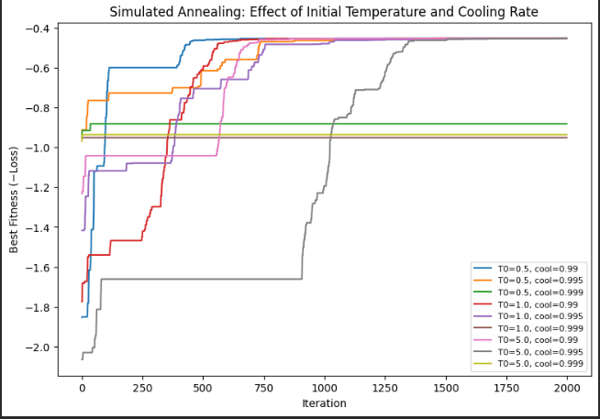

Task 3 – Performance Comparison
Performance Comparison
In this task, the optimization algorithms were compared in terms of classification performance and execution time.
For each algorithm, the best configuration (based on test accuracy) was selected from the hyperparameter experiments conducted in Task 2.
The comparison metrics include:
Best Test Accuracy
Best Test F1-score
Training Time (seconds)

Results and Discussion
Table X summarizes the best performance achieved by each optimization algorithm.
Gradient Descent (GD) and Stochastic Gradient Descent (SGD) achieved similar accuracy with moderate training time.
Newton’s Method achieved competitive accuracy with the fastest training time, due to its second-order optimization.
Genetic Algorithm (GA) required the longest training time because of its population-based nature.
PSO and SA achieved comparable accuracy to GD and SGD but with higher computational cost.
Figure X compares the best test accuracy across all optimization algorithms, while Figure Y compares their training times
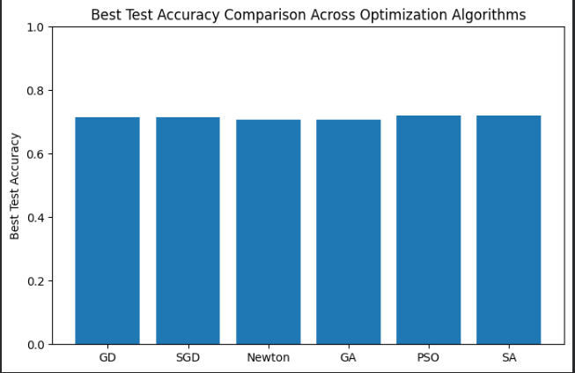

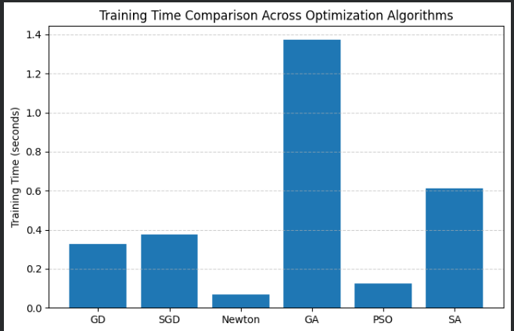

Effect of Reducing Training Rows
To study the impact of dataset size, the training dataset was reduced using different ratios:
Training data ratio ∈ {1.0, 0.5, 0.25}
All optimization algorithms were retrained using the reduced datasets.
Results and Discussion
Figure X shows the effect of reducing training rows on classification accuracy.
Reducing the number of training samples generally leads to a decrease in accuracy.
Gradient-based methods show more stable behavior under reduced data.
Metaheuristic algorithms (GA, PSO, SA) are more sensitive to smaller datasets.
Training time decreases as the dataset size is reduced for all algorithms
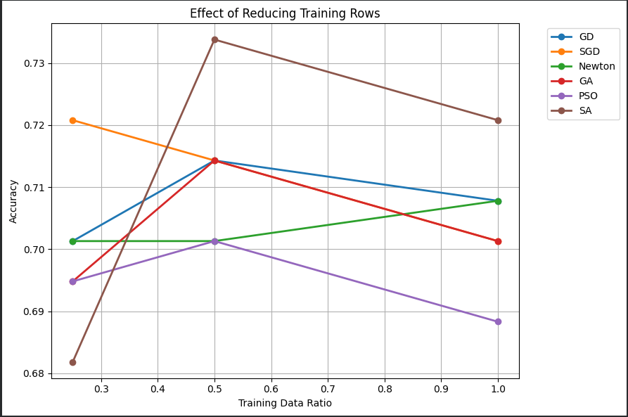

Effect of Reducing Number of Features
To analyze feature dimensionality, experiments were conducted using subsets of:
Number of features ∈ {8, 4, 2}
All algorithms were retrained using the reduced feature sets.
Results and Discussion
Figure Y shows the effect of feature reduction on accuracy.
Reducing the number of features causes a slight degradation in accuracy.
The performance remains relatively stable, indicating redundancy in the original feature set.
Gradient-based and metaheuristic algorithms exhibit similar trends
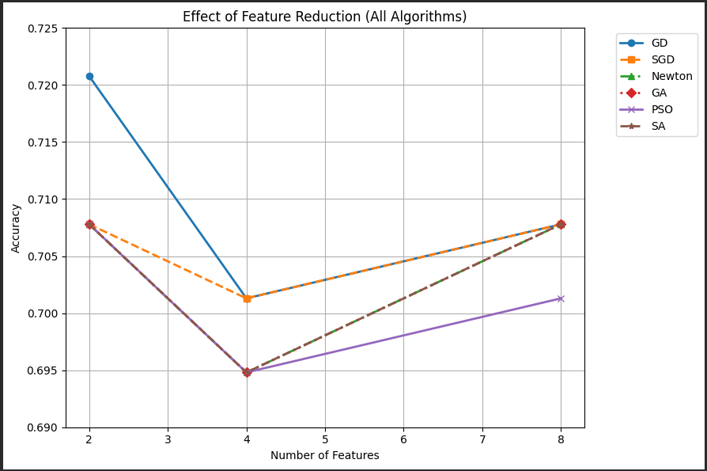

Task 4 – Feature Selection Using Optimization Algorithms
Feature Selection Using Genetic Algorithm
In this task, a Genetic Algorithm was used to perform feature selection.
Each chromosome represents a binary vector indicating whether a feature is selected (1) or not (0).
The fitness function combines:
Classification accuracy
A penalty term proportional to the number of selected features
This encourages selecting a compact feature subset while maintaining high accuracy.

Results and Discussion
The Genetic Algorithm successfully selected a reduced subset of features while achieving comparable classification performance to the full feature set.
Figure Z shows the convergence behavior of the Genetic Algorithm during the feature selection process.
The fitness value increases rapidly in early generations.
The algorithm converges to a stable solution after a small number of generations.
The selected feature subset reduces model complexity without significant loss in accuracy.
A comparison between using all features and GA-selected features shows that similar accuracy can be achieved with fewer features
